16.67: a) b) See Problem 16.66 or Problem 16.70; the difference in frequencies is

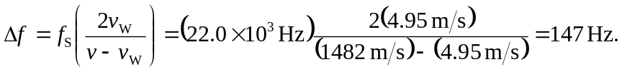

The reflected waves have higher frequency.

